Metropolitan Police Learning Event
Final Report
MutualGain – May 2023

Introduction
In 2020, the Metropolitan Police asked MutualGain to deliver a series of strengths based engagement events in three areas of London. The three areas selected were:

- Acton
- Hayes
- Hounslow

The programme was overseen by Inspector Dan Lipinski from Met Police and Dr Andrew Fisher from MutualGain.

The objective of the programme was to seek to develop, with key partners, a social inclusion approach across three pilot sites within the area. The aspiration was that a social inclusion approach will create community cohesion that enables complex and diverse communities to identify and resolve local issues.

The Met Police recognised the importance and opportunity presented by neighbourhood policing teams seeking to challenge and redesign their approach to policing communities in the three areas, although it is important to note that the key engagement programmes were concluded prior to the launch of the Metropolitan Police Turnaround Plan. MutualGain were asked to link in with the neighbourhood teams in each area and connect with key partners. The reach of the programme included the involvement of local residents in each of the three areas.

It was decided that the approach would be to deliver a listening event, World Cafes, in each area, followed by a Participatory Budgeting (PB) programme and a final learning event.

This report contains the thoughts views and experiences of many of the residents and statutory partners from all three areas.

Learning Event

The learning event was developed in conjunction with Inspector Lipinski who has been the Metropolitan police lead for some time. The learning outcomes were agreed to enable those who attended to share the impact of their programmes as well as capturing their individual learning.

Attendance

In all, over 60 people from across the four areas were invited to attend. A number sent their apologies and others failed to respond. The result was that 30 people attended. There were representatives from partners and community groups from all three areas. In terms of neighbourhood teams, Hounslow was represented by two members of the neighbourhood team and Hayes was represented by two officers, including Inspector Lipinski. Acton did not send a police representative.

Those who attended gave up three hours of their time on Wednesday 17th May 2023 at Botwell Green Library, Hillingdon.

Activities

The key questions asked at the learning event were as follows:

- How have you used the funds that you were awarded/what connections have you made?
- How could this programme benefit you and your community?
- What skills or knowledge have you gained from this programme?

The process of answering these questions was undertaken via face to face facilitated discussion using a variety of methods. The responses to the questions are shown below under the systems that were used.

Further feedback was collated on Post It notes with a view to creating a Word Cloud. This is shown at the end of this report.

Face to face learning event

Task One: How is your programme progressing?

For the first question, participants were asked to share the area that they were from and the group they represented. They were then asked to give an overview of the programmes of their programme as a result of the funding received via the Participatory Budgeting programme.

The responses are shown below. Please note that this is a very brief synopsis of some outstanding work being undertaken in their respective areas. Further information can be supplied on request:

Hounslow

Ivy Bridge Boxing Club
The boxing club submitted three bids to the Hounslow PB programme and was successful in all three. As a result, they are seeing between 60-100 young people using their resources to keep fit and learn about disciple and good behaviour. The focus of the gym is to encourage young people to remain in education and gain knowledge that will help them in later life. In the words of the presenter, they are seeing the behaviour of ‘the clowns’ change. This was felt to be very positive. Further to this, they are seeing great diversity among those who use the gym and one of the supported projects, aimed at helping women address violence against women and girls (VAWG) is now seeing a mixed class.

As a footnote, John Holland, who was the lead presenter at the PB event, was unable to attend. He contacted MutualGain and explained that he recently lost his son, Reece, in a violent attack. The members of the gym have been very supportive, but those present wanted to extend their sympathies to John and his family.

Our Barn, Hounslow Respiratory Group
This programme had two successful bids in the PB programme. Essentially, they are undertaking two programmes that engage up to 20 young people. Part of the programme involves capturing the views of young people via film with filming and editing equipment purchased to accomplish this. The focus of this programme relates to the health and welfare of young people in the area. The success of the programme has resulted in it being adopted by an Arts and Wellbeing group.

Convent Way
This programme arranged an outdoor picnic for the community in a new, unused outdoor space. The programme was designed to improve connections and networks across the community and reduce isolation. ‘A great mix’ of 40 people took part on the day. The feedback was very positive with a request for a further event in the summer. This is being planned by the Convent Way group.

Disability Gardening Project
The Disability Gardening Project is delivered by Donovan Taylor and is designed to help the disabled community by doing their garden for them. The programme helps 16 people and as a result of the PB funding, Donovan has been able to expand the services that he offers to include ‘handyman’ work. The feedback from those that he helps has been positive as they are now able to enjoy their gardens.

Sunshine of Hounslow
Sunshine of Hounslow have been involved in the programme since the World café in Hounslow in October 2021. This is a successful, ongoing programme that in this instance, received funding that allowed them to take 52 members of the community on a trip to Little Hampton. The trip was designed to help those who were less mobile, vulnerable or suffering from isolation to meet in a social setting and to see how they can help each other. A short film was made of the event and can be viewed here.

Refugees Welcome Hounslow
This is another successful ongoing programme that seeks to help up to 20 households from Syria, Sudan and Afghanistan settle into their new homes. The provision includes access to books, information on diet, nutrition, resources and health advice for refugees. Refugees Welcome Hounslow also provide items of home comforts as well as clothes and laptops. Up to 20 households benefit from this programme, which has now achieved charitable status. The programme also acts as an adviser to the local authority.

New Positive World
This programme records community events with a view to sharing positive stories about culture and integration. The programme has had films shown on Sky Arts (channel 711) and YouTube. The programme filmed the Sunshine of Hounslow project referred to above. The programme also promotes community events through their social media platforms.

Hayes

Qoys Dayreel Family Centre
This programme is designed to support the parents of teenagers and bridge the gap between children of families that were not born in the UK and those that were. This extensive programme has gained the support of a youth worker to support parents and has connected with Stepping Stones to support the parents of teenagers. The programme also holds a bi-weekly online workshop, which is very popular.

YMCA
This is an ongoing project t that reaches around 60-90 people per week. The focus is on the physical and mental health of young people with three football session per week for 10 – 16year olds, one of these is for girls only.

Botwell Green Library
The Botwell Green Library team have been involved in the programme from the first World Café. The focus of this programme is to support young people and reduce levels of anti social behaviour. They were successful in their funding bid in the PB programme and now hold after school sessions on Monday – Friday for around 20-30 young people. As well as offering books to people, the library has managed to create a link for outreach support, provide art equipment and transport, thereby extending their reach. They also offer a ‘Teams’ room top help improve levels of communication.

Hayat Lifeline
Hayat Lifeline Women Advocacy group based in Hayes and Harlington community centre, provides activities for local people with a view to improving access to services, economic and community education opportunities, better welfare and housing rights, access to legal rights, reduction of anti-social behaviour/harassment, and better life opportunities. This programme has been delivering this through a series of social events, including Zumba classes, a women’s group, well being and yoga classes and coffee mornings. The programme has helped over 40 people in a short time and anyone is welcome to participate.

Acton

Talking and Exploring
This programme takes groups of people on educational walking tours around the Acton area. There are usually mixed groups of 20 involved, and they learn about resources in the area as well as historical connections. There is a focus on connecting new communities to the area with the offer of social gatherings at the end of the tours. This is a very popular programme and links to films recorded can be found here.

Living Rooms
This programme has been in existence for over 1 years and provides a great deal of support to young people in the area. Living Rooms works in schools and on the streets of Acton in order to provide a listening space for young people. The programme attracts around 40 young people per week.

Hearts in the Community
In the region of 90 people are involved in the delivery of this programme. The programme includes story telling for 2 – 4 year old children and the establishment of a community garden. The groups meet three times a week and at the end of 2022, a Christmas event was held for the community. There has also been an open mic event that attracted local people. There are activities for toddlers through to teenagers, including a youth focused event. The success of this programme is demonstrated by the increasing numbers wanting to engage.

Jamal Edwards Delve
This programme has been working with a group of young women to create a film that reflects their lived experiences. Over 40 sessions have been held with over 40 young people. The film is being edited at the moment. A significant bonus of this programme is that one of the young people involved has gained full time employment as a direct result of participation.

Task Two: What have you taken from the whole process?

In order to gain an understanding of what each project has taken from the programme, those in attendance were asked to share what they have gained from the programme.

When analysed, the comments fell into four broad categories. These are shown below:

- Connections/Networks

We have cemented our relationships with schools and for their parents and children (QD Family Care Centre)
Great to meet Masu and Mercy (Qoys Dayreel Family Care Centre). Helping parents connect

Good link formed with our community sergeant

Connected with young people, schools, local community groups and partners
The boxing club has connected in with Convent Way residents
A real sense of community among local groups

It shows we can all come together and support the community
It shows what we can do with the right help

- Relationships
New relationships formed with police and national Somali helpline (Hayat)
We would like to further cement relationships with the police to further involve them in other projects
We should create relationships with other projects to reach across the borough

Young people from youth clubs in Acton are getting involved in the Acton walks
Deeper relationships with young people from the community
Good long terms relationships began as a result of the programme

- Learning and employment
A walk participant upped her skills making the film of our walk in Acton
Walk participants were shown places, organisations, facilities they never knew existed
Paid employment for young people (NEET) finding their passion

- Communication
Good to hear from other groups, how they are doing and how they spent their money
Nice to see the films if they are open to all who can see them

Supercharging brand promotion and social media outreach
Acton library advertised their events during our visit to a local pub

The objective of the programme was to increase connectivity and networking across the four areas. This is also known as social capital. The comments written above, and the narrative and stories shared in the feedback suggest that this has been successfully achieved. The learning event gave those attending a real opportunity to connect with programmes from other areas, and it was clear that names, numbers and email addresses where being shared.

Task Three: Roots and Fruits

For this exercise, the groups were asked to break into small groups representing their area, and using the materials provided, draw a tree with the phrase ‘How could this programme benefit you and your community?’ written across the middle. This was the collective ambition of the groups involved. Groups then add the resources required to achieve the ambition as the roots, and the potential impact of achieving this ambition as the fruits at the top of the tree. The posters created are shown below:

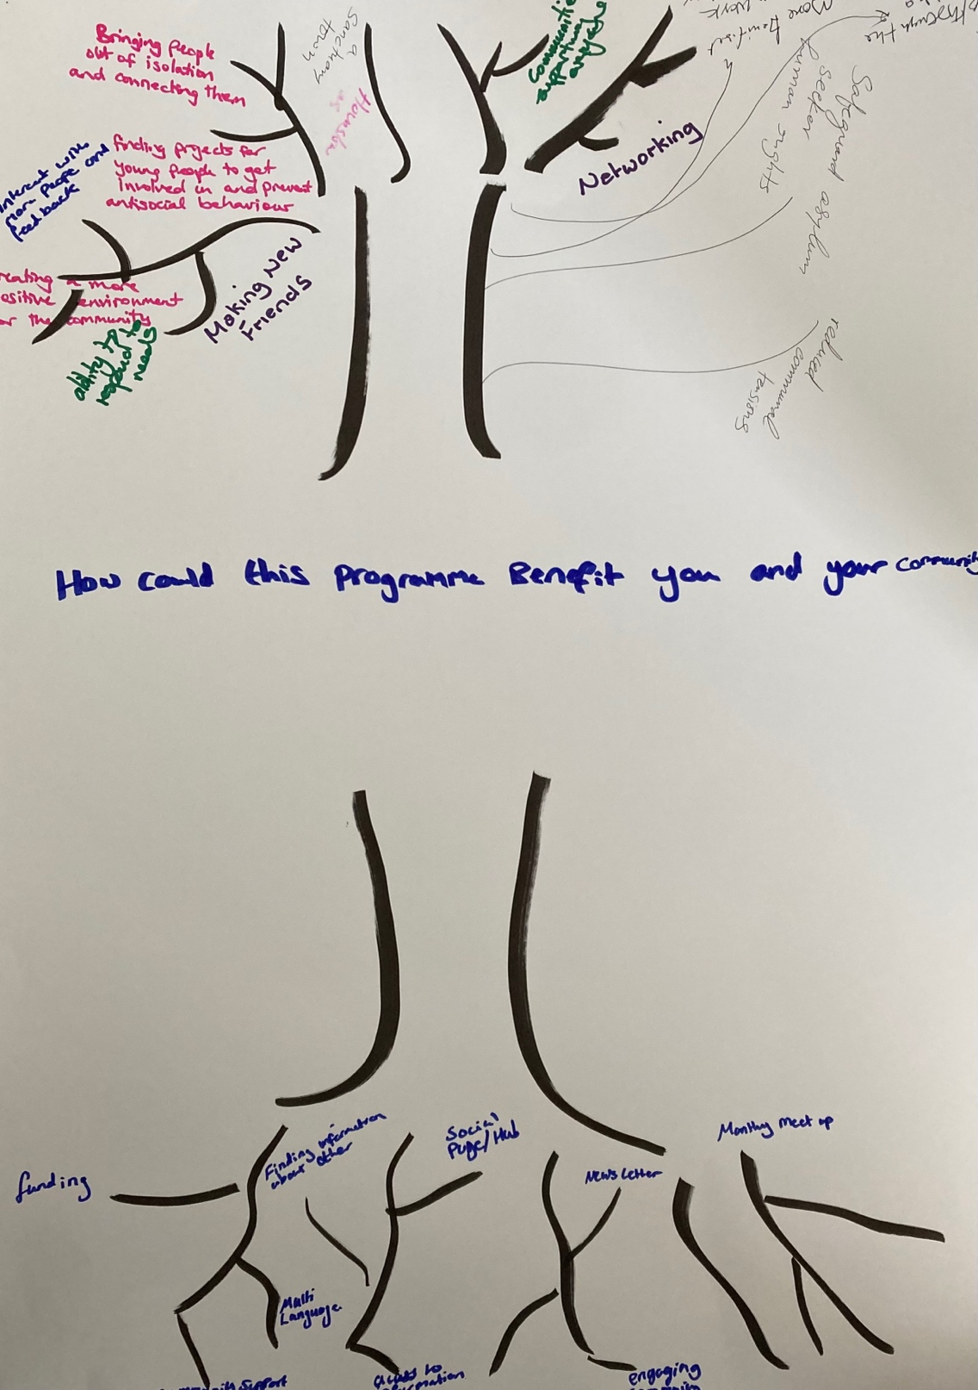

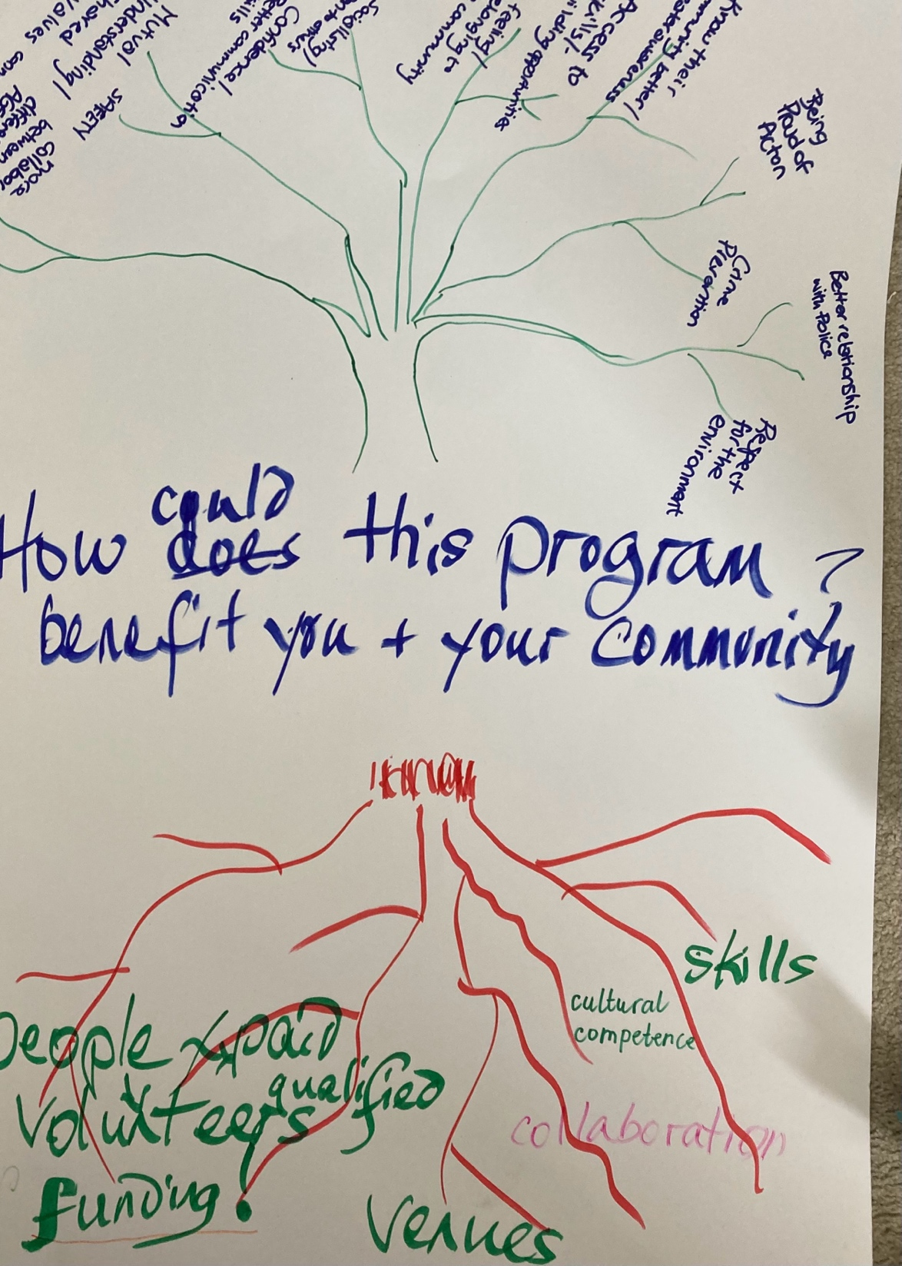

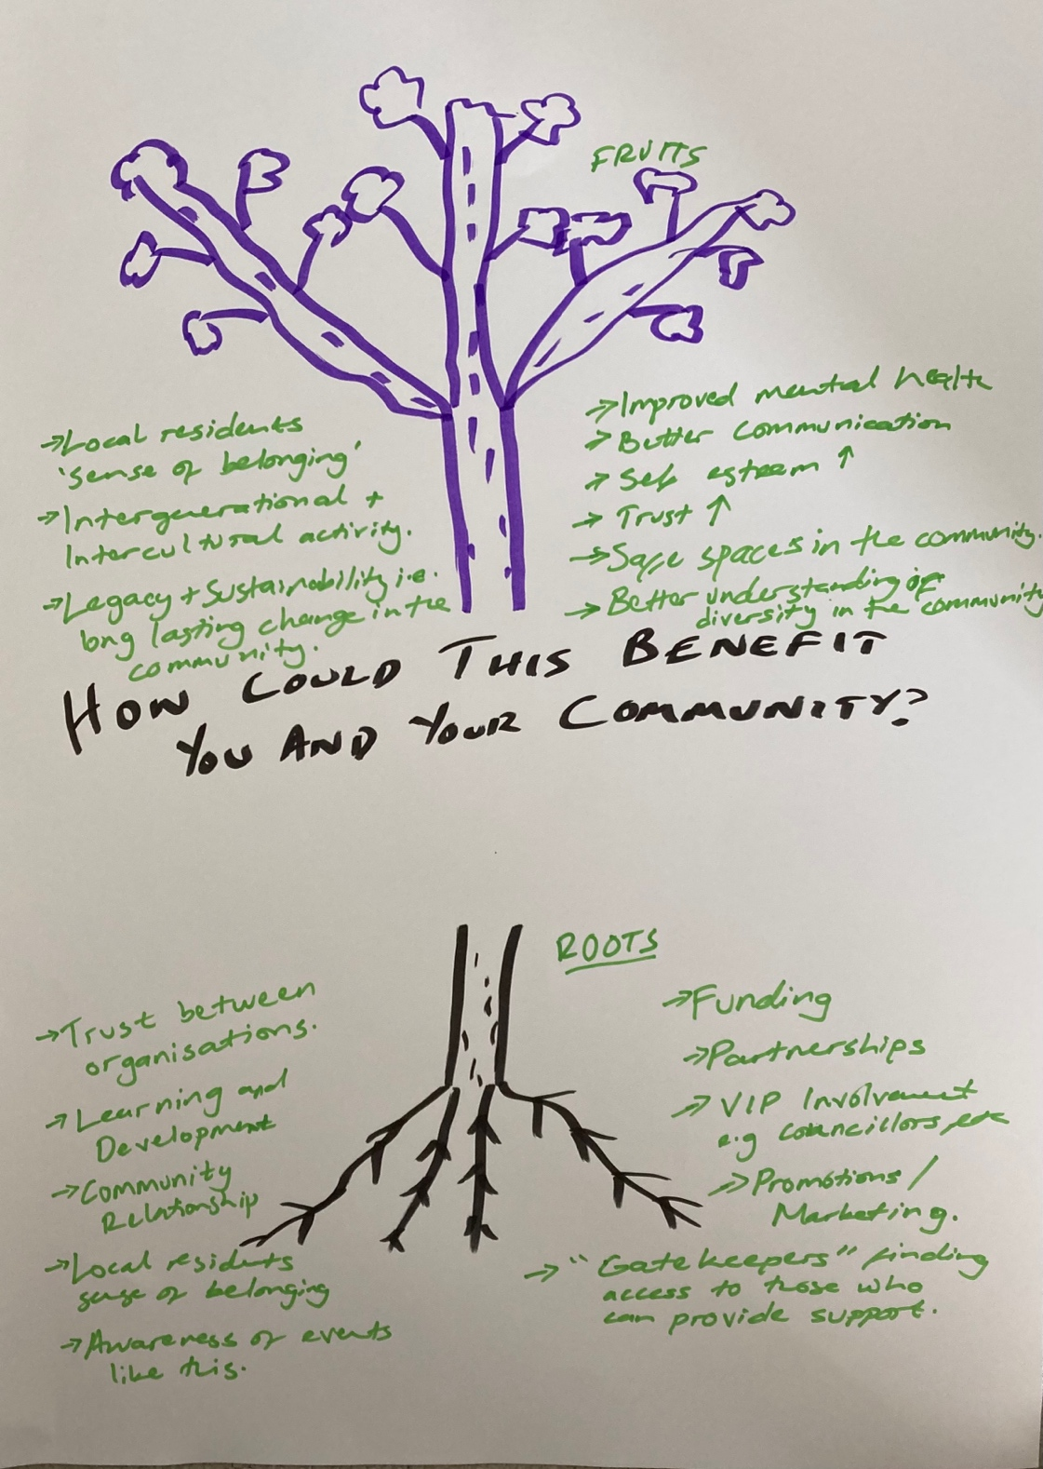

Each team fed back the rational for their choices in relation roots and fruits. There were a number of clear lines of association between all three. These included:
Roots
- Continued access to funding and resources
- Support and training
- Improved communication – including awareness of events
- Continued commitment
- Collaboration with and support from police and other partners
- Increased trust between organisations and the community
- Community support and continued voluntary support

Fruits
- Improved connections and sociability
- Opportunities for self discovery and reduced isolation
- Safe spaces and improved acceptance, including culture and diversity
- An understanding, welcoming, healthy and inclusive community
- Opportunities for employment, skill and learning
- A better relationship with the police
- Increased levels of trust, belonging, self-esteem, and community safety
- Making new connection, creating a positive environment
- Positive promotion of the area, including access to funding opportunities

It was noticeable the resources (rather than funding) of the police and council were missing from the roots. This was a further opportunity for the police and council to offer their commitment and support. There was a positive feeling from participants that with the enthusiasm shown by those attending and the right level of support, the fruits could be achieved.

The level of positivity in relation to community as opposed to self was also clear. This was again evident during the feedback and discussion. There is a real sense of people wanting to improve the lives of their community, making it the best possible place that it can be. The level of volunteering at every level was very impressive and should be a platform for the police and partners to be able to access, connect and build with.

Task Four: What skills or knowledge have you gained from this programme?

This task relates to each individual and is designed to understand what participants have learned about themselves or their community and how they could use this in the future. The comments are shown below:

There are lots of nice people that will help from the community.
There are different ways to connect with the community. Use them.
To share and include all partners at every stage.

There is wealth in the community coming together.
People need to work collectively to ensure a positive environment to improve mental health, diversity and cohesion.
Make better use of teamwork and be patient.

Don’t rely on others, they will do things if you ask them to.
How to better engage young people in a creative process.
I can build a better relationship with the police.

Many groups are working together for the good of their community.
How people come together when given the opportunity.
There is so much we can do in the community. Lots of events for toddlers and adults.

Diversity and different ways of thinking.
There are different networks all with a common goal – community cohesion.
I have learned that community love and innovation is out there.

It shows what we can do if we all pull together.
There are many people out there willing to support their community.
I have learned how to connect and plan with different groups.

Realising how many other inspirational people are working along similar community service lines.
Help is needed for teenage boys. There is a big gap.
Support is available - and the police are proactive in the community.

People need to be informed and be able to share information without being judged.
Work together – we can achieve more.
I learned about set design/technical and film making skills.

Different groups from different communities and organisations need to share what they do.
We have better relationships with the police.
Involve others – delegate!

This has been brilliant
The help and funding is available for building a better community
A number of people are working hard to bring their communities together & helping others to become more skilled and more confident

There is a great deal of wealth and value in the comments shared. There is evidence that participants have benefitted on an individual level, gaining skills, knowledge and connections that they may not have achieved, not least with the police.

Word Cloud
At the conclusion of the event, those attending were asked to share their thoughts about the day in a single word so that a Word Cloud could be created (shown below). However, there were further comments that could not be included in the Word Cloud, so they are shown here:

Today’s session was a great evaluation session. Hope to see more.
Motivation, more confidence and look forward to the next one.
Great event to share information, learn new ideas and plan new projects.

Great for seeing what the issues are.
We need local officers. Great on the beat.
Great for networking.

It was great. Met a lot of different organisations.
Really good to see diversity and diverse projects.

Fantastic. Very engaging, knowledgeable, nice to meet other people.
If you want to see change, sometimes you have to use your own money. But Met (police), council, Home Office, government should be funding in the future.

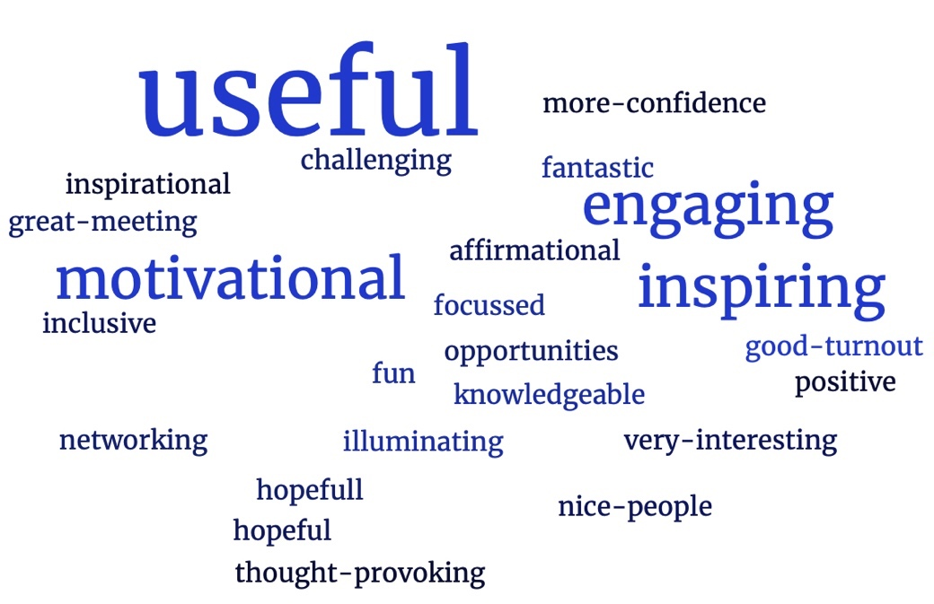

Conclusion

Overall, there are three conclusions that can be drawn from this programme.

The first is that the communities involved were grateful for the opportunities afforded to them in both the World Café and the PB programmes. It is clear they have benefitted from the opportunity to make connections and share resources and that the PB funding was, in some cases, important in helping the development of community programmes.

The second conclusion relates to the role of the neighbourhood policing teams in future engagement. While the individuals assigned to the programme from the police has in some areas been inconsistent, and operational requirements have impacted on attendance, there is still a desire to connect with the police and work with them to address local issues. There was support for the police during the day, albeit there were times when challenges were shared. However, there is a positive baseline to build upon and it is clear from comments shared that the programme has opened doors into ‘hard to reach’ communities.

The third conclusion is that the communities and partner agencies involved have a great deal to learn from each other. This event opened up a number of connections and, subsequent to this event, I have facilitated contact between a number of groups and individuals that wanted to engage and learn from each other. They are now opening up methods of learning, sharing information and resources all to the benefit of their communities.

The role of engaging communities, giving them a voice and an opportunity to participate in shaping their community has been the subject of a great deal of research. In all cases, the opportunity, when well lead and delivered has proven to have had a positive impact. So, I commend those that have taken part and shared their views at this event.

I would particularly like to thank the Botwell Green Library for hosting this event and providing refreshments, and Inspector Dan Lipinski for making himself available to discuss the planning of this event and the potential for the future.

Recommendations

- A police lead (currently Inspector Lipinski) should be identified to continue to provide a link with senior leadership in the Metropolitan police
- In order to further establish relationships with the programmes, they should be visited by the respective neighbourhood policing teams
- Further consideration should be given to joint training with police, local authority and the community
- A learning event should be factored in every six months to allow the programmes to continue to explore their connections and allow them to share their experiences and insights
- Avenues to allow more people to engage with the police as part of Independent Advisory groups or similar programmes should be explored

Andrew Fisher
Dr Andrew Fisher
Senior MutualGain Associate

