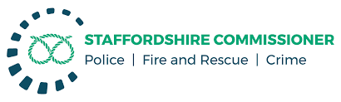

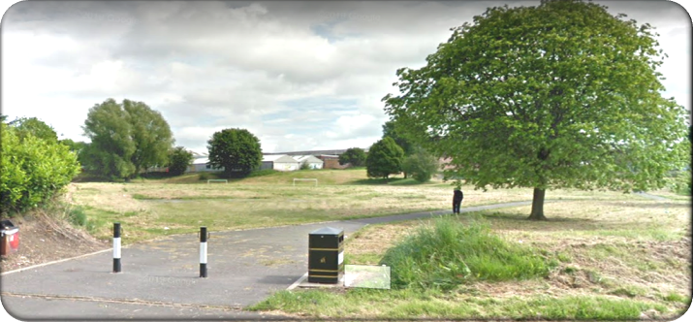

SHELTON SPEAKS

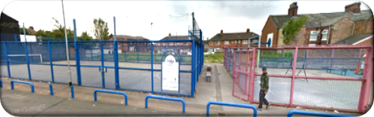

Participatory Budgeting
Event

Submit your bid for up to £3000 for projects that will improve community safety and build a healthier, safer Shelton.

Following on from the ‘Shelton Speaks’ World Café Event that was held on 16th February 2020, Staffordshire Police are working in partnership with the local community to invite bids to spend a £20,000 grant from the Staffordshire Police and Crime Commissioner.

How does the PB process work?

The Shelton community will decide who will be awarded the money based on the projects that they like the most, the process is as follows:

- Groups/organisations can submit an application for funding as per the agreed criteria
- The application form is checked to ensure that it meets the full criteria (set out below)
- The applicants will be invited to attend a Participatory Budgeting Community Event (decision day) and share their ideas with the local community.
- The Shelton community will be given the opportunity to register to attend the decision day and vote for their preferred project(s)
- Votes are counted on the day, and the winning projects will be informed before the event closes

What is the theme for bids?
What can you use the money for?
The money is to be used to support local groups, assisting them to improve community safety and build a healthier Shelton. All bids MUST have a connection to:
- Community Working Together
- Drugs misuse
- Anti-Social Behaviour

ELIGIBILITY CRITERIA – who can apply for funding?
- The maximum bid limit is £3,000 (smaller bids are welcome)
- A single organisation can submit a maximum of three bids, but they must be in relation to separate projects and cannot exceed £5,000 in total
- Those bidding can be from public or private groups
- Bidders can be from outside Shelton, but all projects MUST for the benefit of the community of Shelton and MUST be delivered in Shelton.
- Both constituted and un-constituted groups can apply however, groups MUST be sponsored or have the support of a constituted group e.g. a registered charity
- Bids are welcome from voluntary or community groups, but bids from small or large businesses will be accepted provided they match the eligibility criteria
- The voting process will take place on Saturday 5th December 2020
- THOSE ATTENDING HAVE TO VOTE ON ALL BIDS PRESENTED ON THE DAY
- Bids MUST be submitted to SheltonSpeaksPB@gmail.com
- The closing date for applications is 5pm Friday 16th October 2020. Bids received after this time WILL NOT be considered
- Successful and unsuccessful bids will be informed by email and will be advised of the final stage requirements on Monday 26th October 2020
Follow Shelton Speaks on social media so you don’t miss out on any information.
https://www.facebook.com/CommunitySafetyShelton

If you need help completing your application form, come along to the online drop-in Application Surgery between 6pm and 8pm on Wednesday 23rd September 2020 – Register through this link: https://www.eventbrite.com/preview?eid=121348541755/

Participatory Budgeting Application form

Information about yourself / organisation

Name of your organisation
Name of your
project
Name of main contact
Position in the organisation
Address and
Postcode
Main contact No: |  | Email:

What are you requesting funding for?
Explain what activities/service you will deliver with the funding MAX 150 Words

Who will benefit from your project?
Explain which groups in the community will benefit

What key outcomes/results will your project achieve?
Remember all bids must have a connection to community working together, tackling drugs misuse, ASB

Financial Information
How much funding are you bidding for? How will this be used?
Please break down the costing to a maximum of £3000 or £5000 if you are submitting multiple bids

BEFORE RETURNING YOUR APPLICATION, FORM HAVE YOU…
- Checked the criteria to ensure you are eligible to apply?
- Provided contact details of your Organisation and Project?
- Provided a clear description of the aims of the project and why it should be supported?
- Provided a bid amount?
- Completed ALL the sections of the application form?
- Signed and dated the application form?

Please ensure the application form is submitted by 5pm Friday 16th October 2020.

Please Note – the more information you include in your application, the greater the chance of getting to the final stage
Applicants who get to the final stage MUST be prepared to submit a 3 minute film in support of their application. A surgery will be held to advise and guide applicants on how best to do this.

Conditions and Declaration
I hereby certify that the information contained in this application form is accurate and acknowledge that in the event of a grant being made, the application form and guidance notes will be the basis of a binding agreement.

- The Bid contact MUST be able to attend the online voting event on Saturday 5th December between 1pm and 3pm
- Any bid made will be used ONLY for the purposes for which it is granted
- Any unspent monies MUST be returned in the form of a cheque payable to ‘Staffordshire Police’.
- Applicants MUST be willing to participate in any promotion in relation to the event. This includes sharing their film
- Applications MUST be submitted by 5pm Friday 16th October 2020
- Applications MUST provide details of the bank account that the money is to be paid into
- All successful projects must agree to be subject to a monitoring process
Please tick this box to confirm that your or your organisation has a bank account that funds can be paid into in the event that your application is successful

I understand that failure to comply with the above requirements may result in the recovery of monies paid
Name:

Signature:

Date:

Position:

THERE WILL BE A PROCESS OF REVIEWING THE BIDS TO ENSURE THAT THEY MEET THE ABOVE CRITERIA AND THAT THEY ARE LEGAL.

