World Café Supported Delivery 1

Date: Monday 22nd November 2021
Venue: Connaught School, Melvin Square, Bristol
Time: 6:00pm-8:00pm
Area of focus: World Café Supported Delivery 1

Attendees:

Name | Organisation
Andrew Fisher | MutualGain
Antigua Riley Corion | MutualGain
Steph McKenna | Avon and Somerset Police
Dan Ashfield | Avon and Somerset Police
Joe Markey | Avon and Somerset Police
Mark Thomas | Avon and Somerset Police
Hannah Cheney | Avon and Somerset Police
Terry Black | Bristol City Council
Sophie England | Bristol City Council
Denise Clifford | Youth Moves
Levi Hodge | Youth Moves
Elliot Carr | Youth Opinions
Macey Lefeuvre | Youth Opinions
Harvey Betty | Youth Opinions
Cj Fitton | Youth Opinions
Lily Weston | Youth Opinions
Olivia Booy | Youth Opinions
Carol Casey | Resident
Rachel Heaton | Resident
Nick Haskins | Resident
Paul Coyne | Youth Moves

Introduction

Andrew introduced the session, welcoming all participants to the programme and getting them to introduce themselves. He then described the outline of the programme. The programme will focus on a strengths-based engagement technique known as World Café. He described the focus of the programme supporting young people to emerge from COVID-19.

The room was set up as a World Café in order to give people an understanding of what it will look and sound like. The set up and feel for a World Café is important as this gives people a feeling of welcome and allows them to settle into the event.

Learning Activity:

- Overview of the World Café programme
- Agreeing the branding and logo for our event
- Deciding on the incentive that can be used to attract our target audience (primarily young people)

Naming the World Café

The group were sat in small groups and they were asked to develop ideas for the branding for our event. Ideas were then written onto sheets across the walls and each table was asked to give an explanation as to their proposed brand.

After this, each person was given five coloured dots and asked to place them on their preferred brand. See below
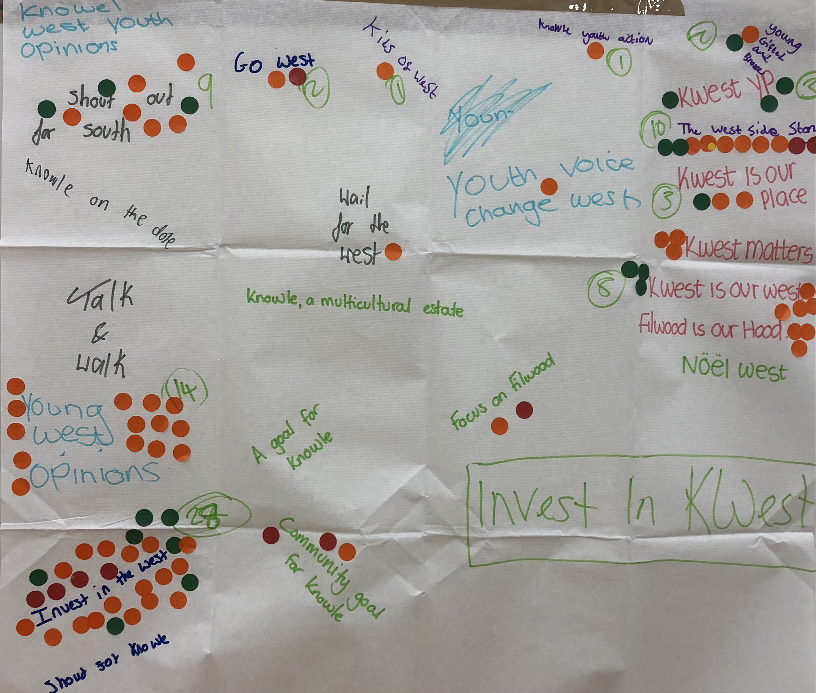

Invest in the West was the preferred choice, however, it was suggested that this was amended slightly to read Invest in K.West – so that it had a stronger connection with Knowle West.

In terms of a logo, each table was asked to design a logo that could be used to represent the brand and the area. Each group shared their design with an explanation.

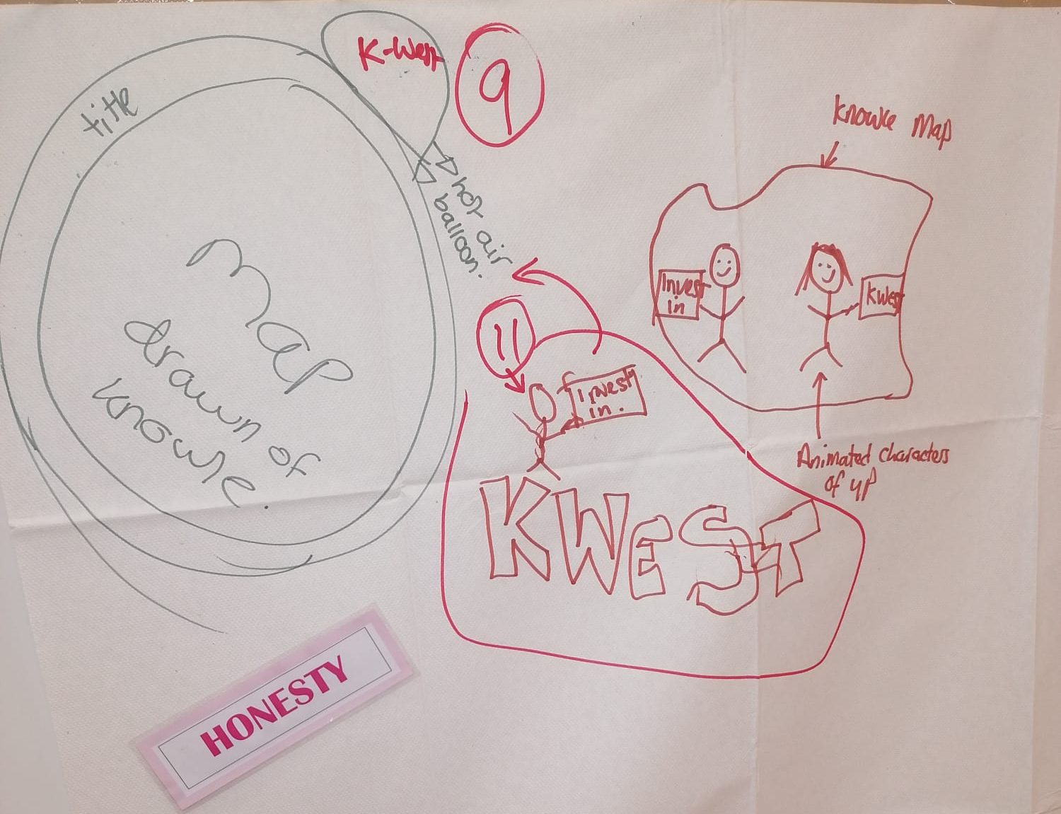
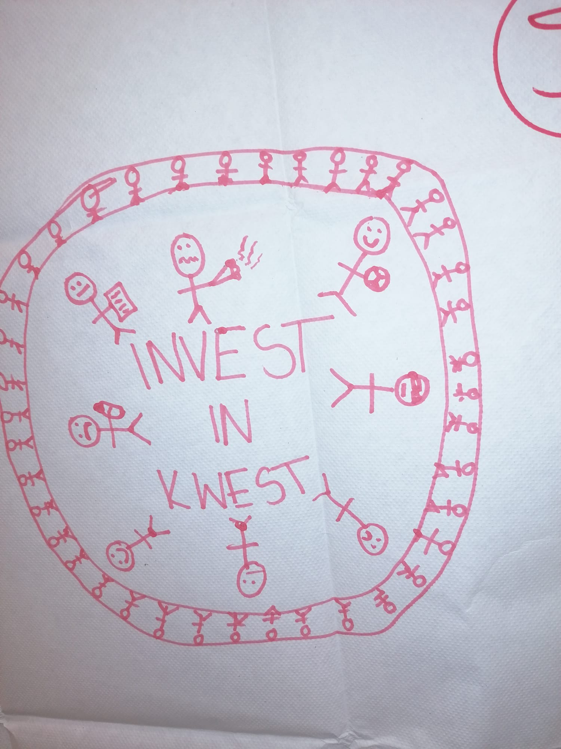

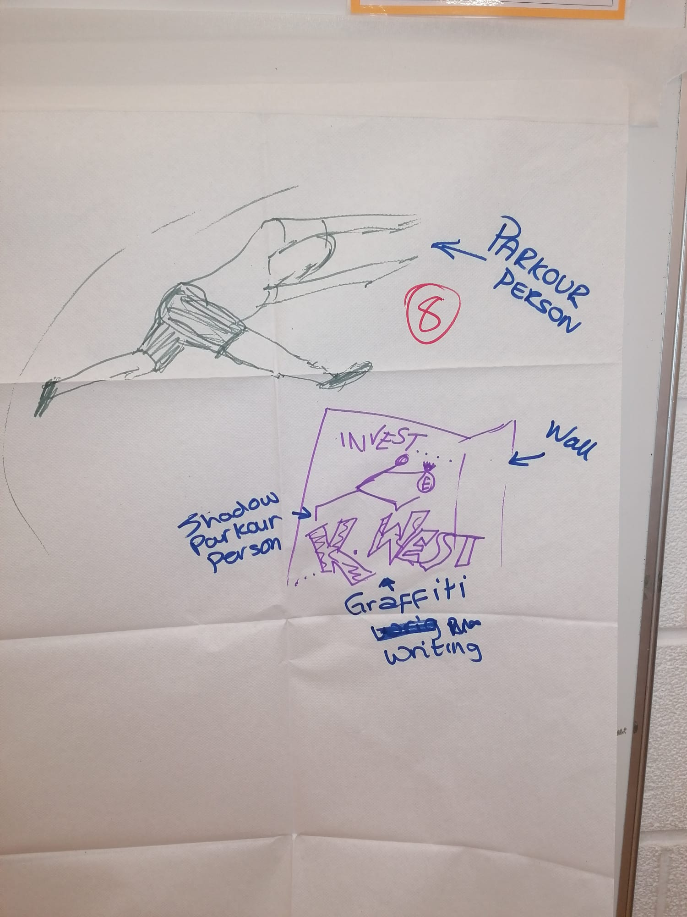

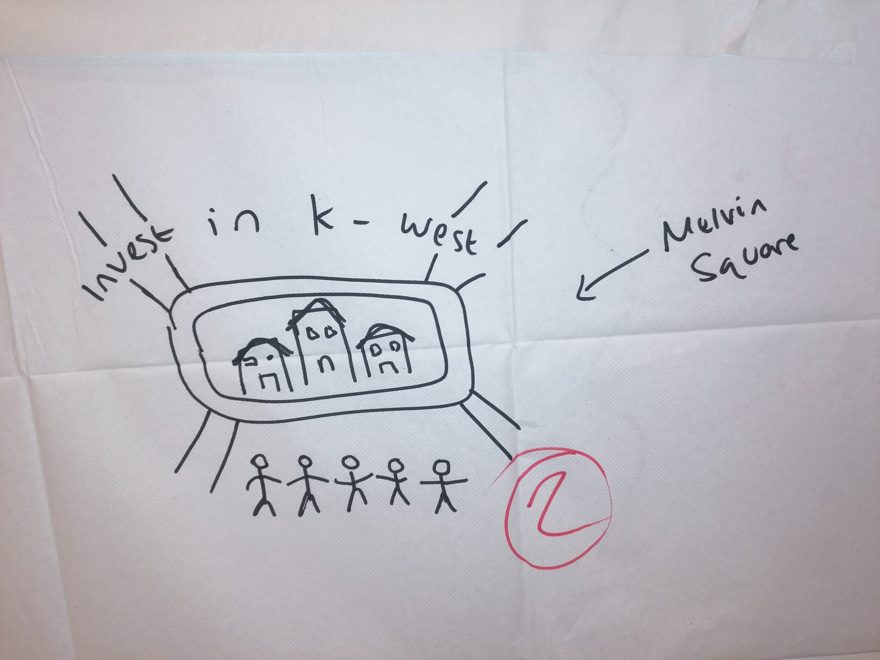

After voting, the group had decided to incorporate the designs in the second picture. Using the hot air balloon with ‘K West!’ written in the centre, and a young person holding a protest sign saying, ‘invest in’.

One of the young people from youth opinions will be creating the design by the next session.

Action: Elliott to create logo design

Elliot agreed to turn the sketch into a logo with the help of Harvey. Both Antigua and Steph agreed to help with the preparation of the final design.

ACTION: Antigua to follow up with Elliot and Harvey and a draft design/s to be shared at the next meeting

Incentives

The group were asked to consider what incentives would attract young people to the event. Options included cash, high street/shopping vouchers, tickets for cinemas etc.

It was agreed that £10 cash would be suitable as we would then be able to incentives up to 100 people. However, the usual process to access this is through a registration process. It was agreed that this may preclude some people, so Elliot proposed that 50% (£500) would be used to encourage people to register and 50% would be used to incentives those who turned up on the day.

ACTION: MutualGain to set up a process to allow this to happen.

Word Cloud

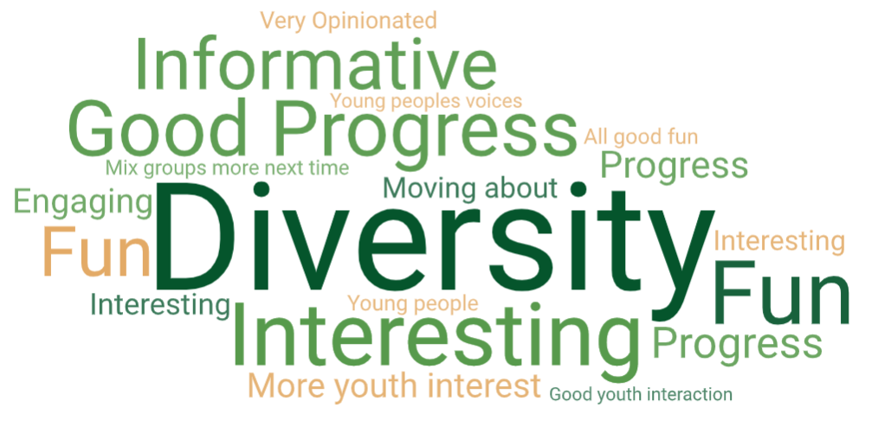
At the conclusion of the meeting, people were asked to share one or two words about the evening that could be made into a Word Cloud. This is shown below:

“It was good that we could all come to a decision on something together. We all had our differences but we came to an agreement.”

Concluding comments

Overall, this was an excellent meeting with most of the actions required for the event being agreed. The focus for the next meeting will be finalising our logo, considering our target group and starting to plan for our event. We will also start to look at roles required for the World Café

Next Meeting

Monday 6th December from 6pm – 8pm at the same venue.

Thanks go to the police for organising the drinks and the venue, and Terry and Denise for organising the food.

